**PART 1**

Result after running script provided: <https://www.up.ist.psu.edu/documentation/IST210/D3WgqIrD/FLIX2YOU_data_load.txt>

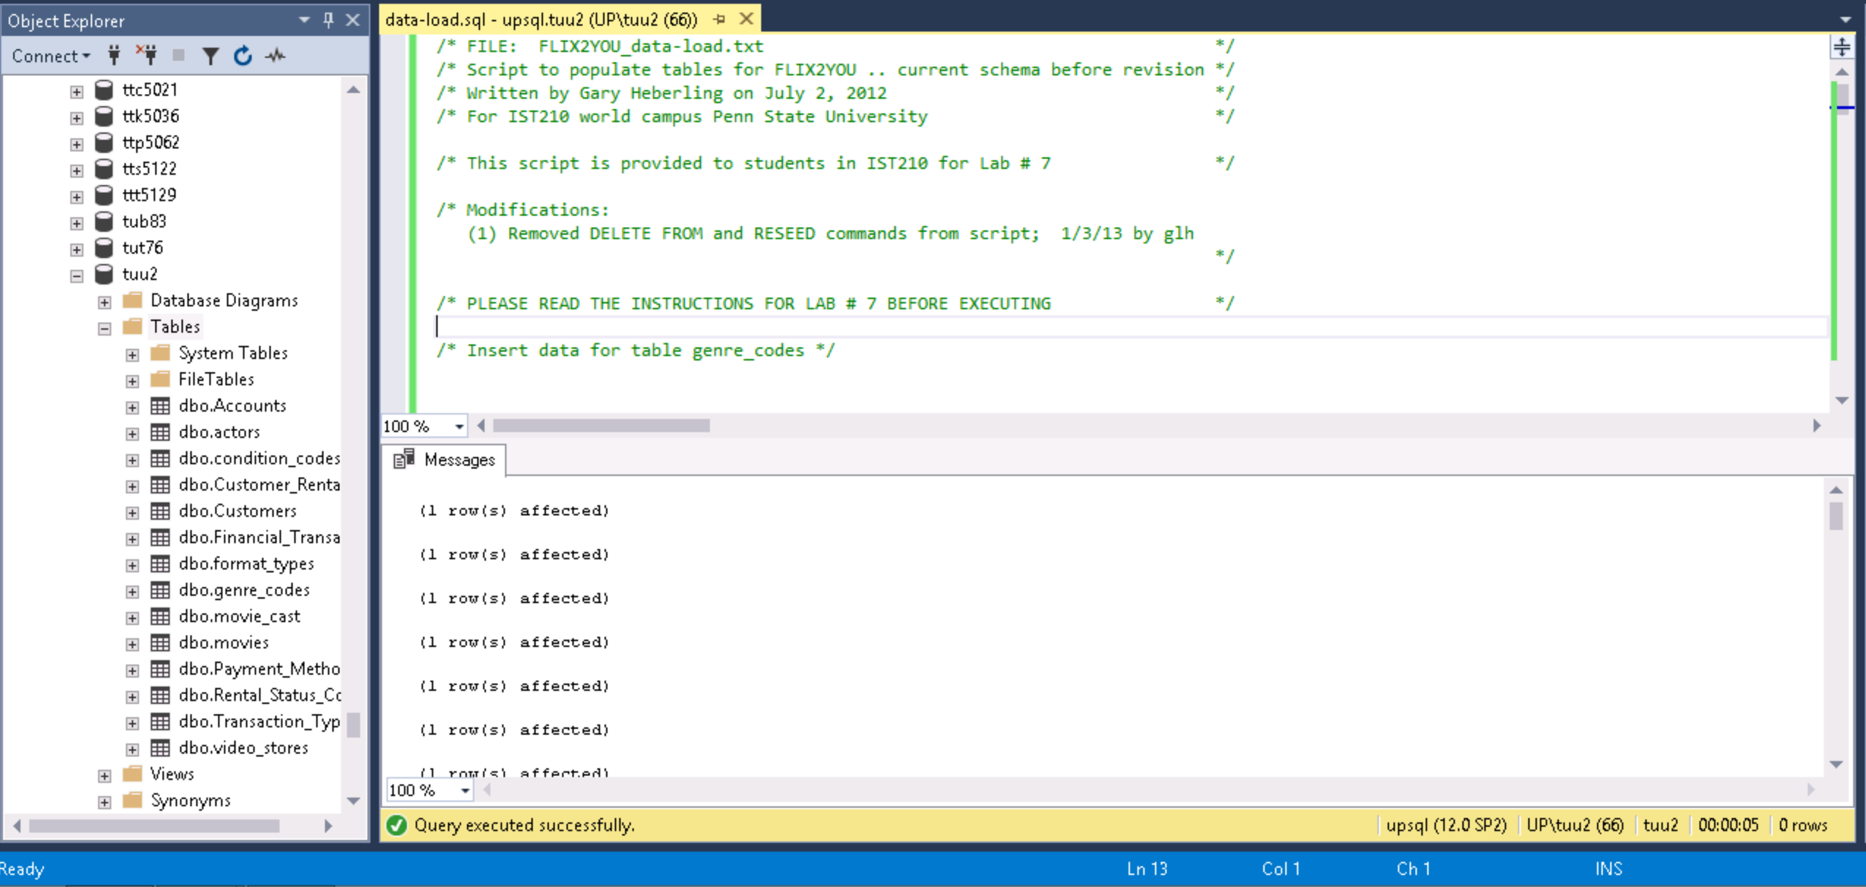

**PART 2**

You will insert data into 2nd set of 7 tables. These are the tables that you wrote the SQL to create the 2nd set of 7 tables in Lab #6. The values that you will insert are provided below. Some data fields are not provided. Please create the necessary values for data that has not been provided. Note: you will need to create the data in the background tables so that foreign key constraints will be satisfied. ALL 7 RIGHT HAND TABLES WILL NEED DATA INSERTED. You will copy/paste the commands you execute along with the messages displayed from the execution of all your commands.

**PART 3**

In this part, you will be updating data to correct some errors. Note that the update may not be a single simple command but rather a series of commands if a field identified as a primary key needs modified. You will copy/paste the commands you execute along with the messages displayed from the execution of all your commands.

Write the SQL code to fix the following “errors”:

1. Murphy's zip code should be 16061.
2. Smith did not rent Superbad but rather Good Will Hunting. The mistake was made by the clerk in the store so there is no change in the amount of the rental.